# Media Analysis - Is the Arab world ready for the uncertain age of AI-powered web tools

## Short Summary

": "The article examines ChatGPT, a significant advancement in AI technology, focusing on its capabilities and limitations, and underscores the necessity of human intelligence for trustworthy AI implementation amidst diverse stakeholder perspectives."  
}

## Summary

1. In the rapidly evolving world of artificial intelligence (AI), systems like ChatGPT are making significant strides, offering a blend of creativity and utility across various domains. Developed by OpenAI, ChatGPT is based on large-language models trained on billions of words gathered from diverse text sources, including books, articles, and websites.  
2. These language models generate text in response to the prompts they receive, demonstrating impressive capabilities such as generating coherent essays across different subjects like law, medicine, or business. They're capable of writing reports, emails, social media posts, legal documents, medical summaries, and responses to customer inquiries among other tasks.  
3. However, while ChatGPT's performance is impressive, it does not possess human-like intelligence or consciousness. It can generate text that appears coherent but lacks the nuanced understanding, emotional depth, skepticism, and reasoning abilities inherent to humans. As Jenna Burrell, director of research at Data Society, highlighted, AI models like ChatGPT are pattern-matching machines, not true understanding systems.  
4. Despite these limitations, AI's potential is immense, with forecasts valuing the market for AI solutions trillions of dollars worldwide. It has applications in entertainment, healthcare, education, and more. However, its integration into these sectors isn't without challenges. For instance, educational institutions are grappling with issues such as cheating when using chatbots like ChatGPT for exams, leading some to revert to traditional paper-based tests or modify exam formats.  
5. Moreover, AI-generated content has been challenged in terms of accuracy and reliability. For example, a report from Minnesota University Law School revealed that ChatGPT passed an exam with a C grade, raising concerns about the authenticity of information produced by such systems. This led to calls for fact-checking as AI's potential for misuse extends beyond academic cheating.  
6. In conclusion, while AI like ChatGPT is advancing and offering promising applications, it still falls short of replicating human intelligence fully. It's crucial to approach the use of such technologies with caution and emphasize maintaining trust by combining them with human intuition and expertise for better outcomes. As we progress into this age of AI, fostering a symbiotic relationship between humans and machines will be key to maximizing their benefits while mitigating potential risks.

## Question 1:

How do the media in this article frame the public discussion about ChatGPT? Are there certain **metaphors** that keep cropping up?

The media in this article frames the public discussion about ChatGPT by comparing it to text-generating AI, mentioning its capabilities as an 'AI model capable of writing essays', and labeling it as a 'generative AI'. They also describe it as an 'AI assistant' highlighting its potential to assist with tasks like content creation. These metaphors emphasize ChatGPT's ability to generate text while acknowledging its limitations, particularly in understanding human nuances and creativity.

## Question 2:

Which role does or might the Arabic World play in the development of Artificial Intelligence? Answer with 'Not mentioned' if not applicable.

Not mentioned

## Question 3:

Which use cases of Artificial Intelligence are helpful for the Arabic world based on this article?

Content creation in educational institutions, aiding in various professional tasks, and improving information management through web-harvesting AI tools.

## Question 4:

What is the final message of the article that the author wants to convey? Keep your answer short and precise!

AI's potential benefits and responsible use are highlighted, balanced by acknowledgment of ongoing concerns and the importance of trust in its application.

## Sentiment

The sentiment is <0>

balanced

## Entities

Multinational Tech Corporation Microsoft, Sciences Po School Paris, Linkedin Co, Initial Investment Firm Worth Billion Billion Mean Company Value, James Webb, Chatgpt Spur Google Management, Arab News Leap Technology Conference, Marketing Professional Redundant Technology, Spearhead Uae Expand Digital Economy Middle East Project, Jenna Burrell, Elon Musk Serve Start Board, Dan Milmo Alex Hern Tech, Burrell Say, Sam Altman Year, Peter Thiel Tesla, Uk Guardian Newspaper Say, Omar Sultan Al Olama Take, Research Data Society Independent Non Profit Research Organization Base California Say People Need Chatgpt, Reid Hoffman, Noaman Sayed

## Topic Clusters

### Cluster: AI Ethics and Privacy

ChatGPT, Education Cheating

### Cluster: Misinformation and Fake News

ChatGPT

## Word Clouds

### Wordcloud of content

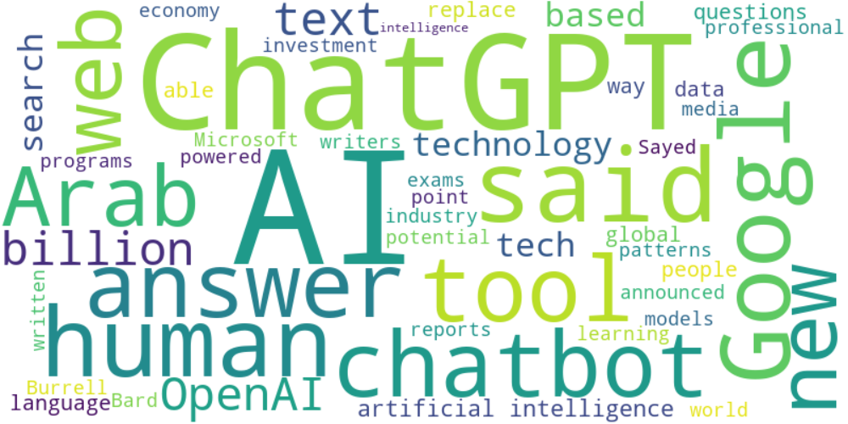

Top 10 words:

- AI: 25  
- ChatGPT: 17  
- said: 9  
- human: 8  
- Google: 8  
- Arab: 6  
- web: 6  
- intelligence: 6  
- OpenAI: 6  
- billion: 6

### Wordcloud of summary

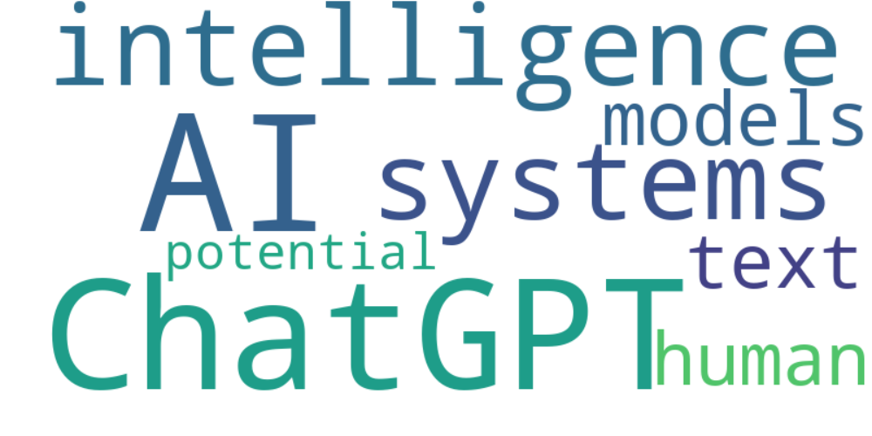

Top 10 words:

- AI: 8  
- ChatGPT: 7  
- like: 6  
- intelligence: 3  
- systems: 3  
- models: 3  
- text: 3  
- human: 3  
- potential: 3